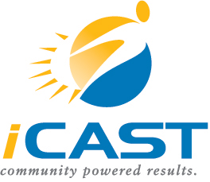

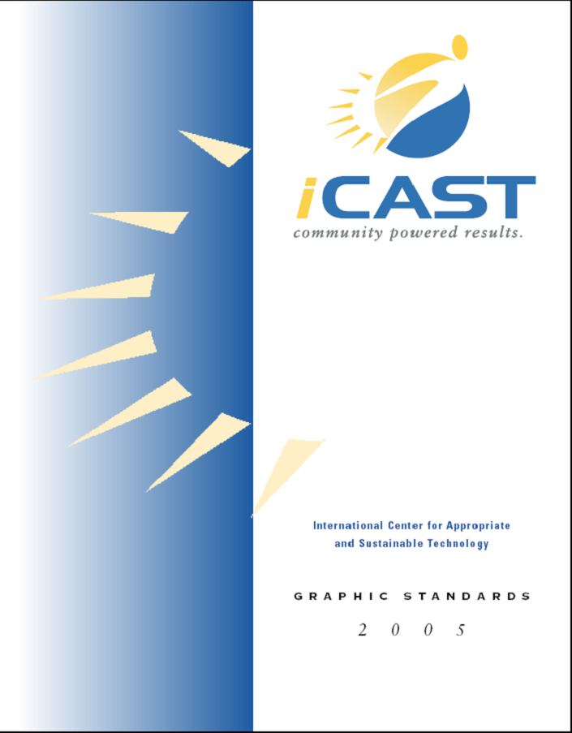
GLOSSARY
OF
TERMS

Contact
Ravi Malhotra
President
Email Ravi@iCASTusa.org
Phone (303) 462-4100
www.iCASTusa.org

Contents
Introduction 2
Glossary of Business Terms 3
Glossary of Renewable Energy Terms 6
Glossary of Energy Efficiency Terms 9

Introduction
This glossary is designed by iCAST to help micro entrepreneurs navigate through the terminology they will encounter in the course of running their business. This glossary will be compiled and additions will be made to provide relevancy to micro-entrepreneurship, green start ups, and small businesses seeking to expand their services and products to provide sustainable impacts. This resource will allow micro-entrepreneurs to become well versed in industry. This glossary is divided into three sections: business terms, renewable energy terms, and energy efficiency terms. The business terms are frequently used terms in entrepreneurial circles, web technology (as the Internet is becoming an integral tool in the business world), and other business terms. Renewable energy terms section has the most frequently used terms for various forms of renewable energy including biomass, wind power, and hydropower specific terms. The energy efficiency section consists of frequently used terms in the case of energy efficiency.

Glossary of Business Terms
Angel investors: Individuals who have capital that they are willing to risk. Angels are often successful entrepreneurs who invest in emerging entrepreneurial ventures, often as a bridge from the self-funded stage to the point in which a business can attract venture capital.
Appreciation: An increase in the value of assets over a length of time or its expected life. The opposite of appreciation is depreciation.

Assets: Items of value owned by a company and shown on the balance sheet, including cash, equipment, inventory, etc.

Balance sheet: Summary statement of a company's financial position at a given point in time, listing assets as well as liabilities.

Breakeven point: Dollar value of sales that will cover, but not exceed, all of the company's costs, both fixed and variable.

Business plan: A written document detailing a proposed venture, covering current status, expected needs, and projected results for the enterprise. It contains a thorough analysis of the product or service being offered, the market and competition, the marketing strategy, the operating plan, and the management as well as profit, balance sheet, and cash flow projections.

Capital: Cash or goods used to generate income. For entrepreneurs, capital often refers to the funds and other assets invested in the business venture.

Capital cost: The total investment needed to complete a project and bring it to an operable status.

Cash flow: The difference between the company's cash receipts and its cash payments in a given period. It refers to the amount of money actually available to make purchases and pay current bills and obligations.

Collateral: An asset pledged as security for a loan.

Corporation: A business form that is an entity legally separate from its owners. Its important features include limited liability, easy transfer of ownership, and unlimited life.

Depreciation: The decrease in the value of assets over their expected life by an accepted accounting method, such as allocating the cost of an asset over the years in which it is used.

Equity: An ownership interest in a business.

Income statement: Also known as a "profit and loss statement," it shows a firm's income and expenses, and the resulting profit or loss over a specified period of time.

Inventory: Finished goods, work in process of manufacture, and raw materials owned by a company.

Joint venture: A legal entity created by two or more businesses joining together to conduct a specific business enterprise with both parties sharing profits and losses.

Liabilities: Debts a business owes, including accounts payable, taxes, bank loans, and other obligations. Short-term liabilities are due within a year, while long-term liabilities are due in a period of time greater than a year.

Limited partnership: A business arrangement in which the day-to-day operations are controlled by one or more general partners and funded by limited or silent partners who are legally responsible for losses based on the amount of their investment.

Liquidity: The ability of an asset to be converted to cash as quickly as possible and without any price discount.

Marketing: The process of researching, promoting, selling, and distributing a product or service. Marketing covers a broad range of practices, including advertising, publicity, promotion, pricing, and packaging.

Networking: (1) Developing business contacts to form business relationships, increase knowledge, expand a business, or serve the community. (2) Linking computers systems together.

Outsourcing: The practice of using subcontractors or other businesses, rather than paid employees, for standard services such as accounting, payroll, information technology, advertising, etc.

Partnership: Legal form of business in which two or more persons are co-owners, sharing profits and losses.

Pro-Forma: Describing documents that are done as a formality or to satisfy requirements.

Principal: A capital sum of finances aside from interest or profit.

Return on Investment (ROI): A performance measure used to evaluate the efficiency of an investment or to compare the efficiency of a number of different investments.
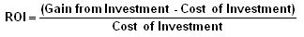

Small Business Administration (SBA): Created in 1953, it is an independent agency of the U.S. federal government that aids, counsels, assists, and protects the interests of small business.

Seed financing: A relatively small amount of money provided to prove a concept; it may involve product development and market research.

Sole proprietorship: A business form with one owner who is responsible for all of the firm's liabilities.

Start-up financing: Funding provided to companies for use in product development and initial marketing. It is usually funding for firms that have not yet sold their product commercially.

Trademark: A form of legal protection given to a business or individual for words, names, symbols, sounds, or colors that distinguish goods and services. Trademarks, unlike patents, can be renewed forever as long as they are being used in business.

Variable costs: Costs that vary as the amount produced or sold varies.

Venture capital: An institution specializing in the provision of large amounts of long-term capital to enterprises with a limited track record but with the expectation of substantial growth. The venture capitalist also may provide varying degrees of managerial and technical expertise.

Glossary of Renewable Energy Terms
Alternating Current (AC): Electricity that changes direction periodically. The period is measured by cycles per second with the unit Hertz (Hz).
Biofuels: Biomass converted to liquid or gaseous fuels such as ethanol, methanol, methane, and hydrogen. The most common forms are bioethanol and biodiesel.

Biomass: Any plant-derived organic matter. Biomass available for energy on a sustainable basis includes herbaceous and woody energy crops, agricultural food and feed crops, agricultural crop wastes and residues, wood wastes and residues, aquatic plants, and other waste materials including some municipal wastes. Biomass is a very heterogeneous and chemically complex renewable resource.

Combustion: A chemical reaction between a fuel and oxygen that produces heat (and usually, light).

Converter: Electronic circuit to convert voltages (e.g., photovoltaic module voltage) into other levels (e.g., load voltage). Can be part of a maximum power point tracker.

Direct Current (DC): A type of electricity transmission and distribution by which electricity flows in one direction through the conductor, usually relatively low voltage and high current. To be used for typical 120 volt or 220‐volt household appliances, DC must be converted to alternating current, its opposite.

Energy: The capability of doing work; different forms of energy can be converted into other forms, such as electric and solar. Energy cannot be created nor destroyed.

Energy crop: A crop grown specifically for its fuel value. These include food crops such as corn and sugar cane, and nonfood crops such as poplar trees and switchgrass.

Fossil fuel: A carbon or hydrocarbon fuel formed in the ground from the remains of dead plants and animals. It takes millions of years to form fossil fuels. Oil, natural gas, and coal are fossil fuels.
Generator: A device that produces Direct Current from a rotating shaft.
Geothermal Energy: A form of renewable energy taken by drawing thermal energy from the Earth’s core to the surface. Geothermal energy can be used for water or space heating or converted to electric power.

Global warming: A term used to describe the increase in average global temperatures due to the greenhouse effect.

Greenhouse Gas (GHG): A gas that absorbs and emits radiation, trapping heat within the atmosphere, and raising the Earth’s temperature. This process is known as the greenhouse effect. Examples of GHGs include carbon dioxide, methane, and chlorofluorocarbons.

Grid: An electric utility’s system for distributing power.

Ground Source Heat Pump: A system that pumps heat from the ground to the surface for heating and from the surface to the ground for cooling. Also known as geo-exchange or geothermal heat pumps.

Joule: A metric unit of energy or work; 1 joule per second equals 1 watt; 1 BTU equals 1,055 joules.

Kilowatt (kW): A standard unit of electrical power equal to 1000 watts, or to the energy consumption at a rate of 1000 joules per second.
Load: Something physical or electrical that absorbs energy. A wind generator that is connected to a battery bank is loaded. A disconnected wind generator is NOT loaded, so the blades are free to spin at very high speed without absorbing any energy from the wind and is in danger of destruction from over-speeding.
Ozone: A compound that is formed when oxygen and other compounds react in sunlight. In the upper atmosphere, ozone protects the earth from the sun's ultraviolet rays. Though beneficial in the upper atmosphere, at ground level, ozone is called photochemical smog, and is a respiratory irritant and considered a pollutant.

Parallel: In DC electrical circuits such as a battery bank or solar panel array, a parallel connection is where all negative terminals are connected to each other, and all positive terminals are connected to each other. Voltage stays the same, but amperage is increased. In AC circuits such as a wind generator alternator, each parallel coil is connected to common supply wires, again increasing amperage but leaving voltage the same. This is the opposite of a series connection.

Photovoltaic (PV) Cell: A device that converts solar energy to electricity. A photovoltaic panel consists of several PV cells.

Power Conditioning: The process of modifying the characteristics of electrical power (e.g., for inverting direct current to alternating current).
Regulator: A device to adjust incoming power so as to avoid overcharging a battery bank. In solar power, the regulator generally just turns the solar array off when the batteries are full. With a wind generator, the regulator generally diverts all or part of the incoming power to a Dump Load when the batteries fill, thus keeping a load on the wind generator so it will not freewheel.
Renewable Energy Certificate (REC): A credit that can be purchased from power suppliers and traded to represent proof that an amount of renewable energy was generated. The REC holder’s energy may not necessarily be from a renewable source but the REC assures that the equivalent amount is produced by a renewable source. RECs are also called Green Tags, Renewable Energy Credits, and Tradable Renewable Credits.
Resistance: The voltage per amp needed to make electricity flow through a wire. See Ohm's Law.
Series--In DC electrical circuits such as a battery bank or solar panel array, a series connection is where all the negative terminals are connected to the neighboring positive terminals. Voltage increases, but amperage stays the same. In AC circuits such as a wind generator alternator, each coil is connected to the one next to it, and so on, again increasing voltage but leaving amperage the same. This is the opposite of a parallel connection.
Short Circuit: 1) Parts of a circuit connected together with only the impedance of the leads between them. 2) In wind generators, connecting the output leads directly together so as to heavily load a generator in high winds. This creates a "short" circuit path back to the generator, bypassing all other loads.
Solar Energy: Electromagnetic energy transmitted from the sun (solar radiation). The amount that reaches the earth is equal to one billionth of total solar energy generated, or the equivalent of about 420 trillion kilowatt‐hours.
Stationary: With wind generator towers, a stationary tower does not tilt up and down. The tower must be climbed or accessed with a crane to install or service equipment at the top.
Thrust: In a wind generator, wind forces pushing back against the rotor. Wind generator bearings must be designed to handle thrust or else they will fail.
Transformer: Multiple individual coils of wire wound on a laminate core. Transfers power from one circuit to another using magnetic induction. Usually used to step voltage up or down. Works only with AC current.
Turbine: A rotary motor driven by a flow of water, steam or wind to produce electrical energy.
Ultraviolet: Electromagnetic radiation in the wavelength range of 4 to 400 nanometers.
Vertical Axis Wind Turbine (VAWT): A wind generator design where the rotating shaft is perpendicular to the ground and the cups or blades rotate parallel to the ground.
Windmill: A device that uses wind power to mill grain into flour. But informally used as a synonym for wind generator or wind turbine, and to describe machines that pump water with wind power.

Glossary of Energy Efficiency Terms

Absorptance: The ratio of a solar energy absorbed to incident solar. Also called absorptivity.
Building Shell: The building's exterior envelope-walls, floor, and roof of a building.
Capacity: The maximum instantaneous output of an energy conversion device, often expressed in kilowatts (kW) or megawatts (MW).

Condensation: The change from a gas to a liquid. Condensation is the opposite of evaporation.
Conductance: The material property to conduct or transfer some energy form like heat or electricity.
Distribution system: A system of pipes or ducts used to distribute energy.
Embodied Energy: The energy required to make a product and the molecular energy inherent in the product material.
Energy: The capability of doing work; different forms of energy can be converted into other forms, such as electric and solar. Energy cannot be created nor destroyed.

Energy Audit: The process of identifying energy conservation opportunities in buildings.
Energy Efficiency: Term describing how efficiently a building component uses energy.
Evaporation: The change that occurs when a liquid becomes a gas. Evaporation is the key process in the operation of air conditioners and evaporative coolers.
Insulation: Material with relatively high thermal resistance. Insulation is vital to maintain a space’s heat.
Main panel box: The service box containing a main switch, and the fuses or circuit breakers located inside the home.
Meter: A device that provides the supplier and customer of energy or water usage.
Passive Heating: Natural heating from the sun without any conversion to electricity.
Passive Ventilation: Ventilation using only natural air movement without using electricity. Also known as Natural Ventilation.
Pressure: A force applied on particles resulting in flow by virtue of a difference in between two areas.
Radiation: Heat energy, which originates on a hot body like the sun, and travels through the air.
Retrofit: An energy conservation measure that is applied to an existing building. Also means the action of improving the thermal performance or maintenance of a building.
Space conditioning: Heating, cooling or ventilation of an indoor space.
Ventilation: The movement of air through an area for the purpose of removing moisture, air pollution, or unwanted heat.
Watt: A unit of electrical power equivalent to one joule per second or 3.4 BTUh.
Weatherization: The process of reducing energy consumption and increasing comfort in buildings by improving energy efficiency of the building.
Zone: A room or portion of a building separated from other rooms by an air barrier-not usually an effective air barrier.

References:
www.nrel.gov
http://www1.eere.energy.gov/windandhydro/hydro_glossary.html
http://www.america.gov/st/business-english/2007/November/20080604000521eaifas0.386593.html
http://www.otherpower.com/glossary.html
http://www.coloradoefficiencyguide.com/glossary/default.htm
http://www.eia.doe.gov/emeu/efficiency/ee_gloss.htm

